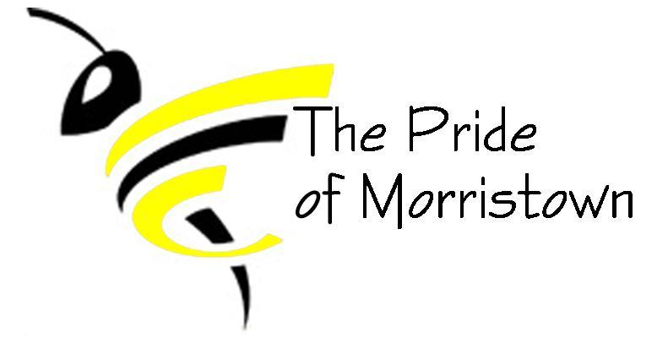
Morristown Band Boosters
Monthly Board Meeting
August 15, 2018

Board Members (X if present):
[ X ] Band Director – Brea Pickett [ X ] President – Tracy Guffey
[ X ] Vice President – Brant Stoner [ X ] Treasurer – Erin Carlton & T. Guffey
[ X ] Secretary – Amber Richardson [ X ] Member At Large – Jenny Kieninger
Other booster members present: Cindy Stoner

Agenda:

Minutes
- Treasurer Report (10 minutes)
  - Current Account Balances
    - Booster (Operating): $15,254.93
    - Instrument: $3,135.11
    - Cash: 0
  - Recent Expenses
    - Bus fees (including Holiday World trip) about $1,000
    - Repairs & supplies (Paige’s Music, from Mr. Black’s time) $217.69
      - We have credits on our Paige’s music account and you must tell them to apply the credits, they won’t automatically use them

  - Recent Deposits
    - Amazon Smile:
    - Kroger:
    - Papa John’s:
    - Sponsorships:
      - $200 Sponsorship for E. Dill
    - Band Fees
      - $100
    - Show Shirt money/instrument rental
      - $25
      - $30
  - Other financial concerns/comments
    - E. Carlton to break down sponsor list for student vs. band sponsors
    - B. Pickett to check to make sure there isn’t any band money in the safe in the school office
    - E. Carlton to check into getting checks for the instrument bank account
    - Staff pay follow-up
      - $500 check to pay Josh for band camp was written
      - Haley & Daniel need to fill out W9 forms
    - Reimbursement follow-up
      - Taylor came to the meeting and received a check
      - T. Guffey to take reimbursement check from drum major camp to Anna Mullet
    - Staff

- Kudos/Happy News (5 minutes)
  - INPact was great! The kids had a blast!

- Key Points/actions from last meeting (15 minutes)
  - E. Carlton brought commitment forms to meeting for B. Pickett
  - Parent practice on Saturday, August 25th @ 8am
    - Practice with helpers getting props on and off the field
    - Clean out the trailers
    - A. Richardson to get down parents/helpers’ info for background checks
  - Props
    - 8 semi-finished (need more paint & “leaves”), need 4 more completed
    - E. Carlton to get material for cauldron
  - Guard Uniforms
    - Black dresses w/ corsets; witch hats (?)
    - $600 total budget for uniforms
      - A. Richardson motioned to allow B. Pickett to order to spend the $600 for guard uniforms; B. Stoner seconded motion; all voted Aye
  - Percussion car repairs
    - Still needed

- Band Director Report (15 minutes)
  - Rehearsal at Triton Central
    - 8/24/18 from 5 to 8 PM
      - Kids can stay after school for Boosters to feed them
      - T. Guffey to bring hot dogs & buns
      - B. Stoner to bring chips
      - A. Richardson to bring water and condiments
  - Athletics concessions
    - Concession stand running to be split between athletics dept., band dept., choir dept. & FFA
    - Athletics dept. to stock the concession stand but we would make a % of the sales the nights we work
    - All department heads will sit down with a master schedule to divided working the concessions
    - Kids can work the concessions with adults
      - Should we allow kids to “work off” some of their over due fees? For every hour they work they get $5 off their fees?
    - If there are no concessions being sold at baseball games we can buy water to sell, etc.
    - We can also sell things in the hallway during games
  - Contest Dates & cost
    - Sept. 8th Decatur Central $250
    - Sept. 15th Brownsburg $250
    - Sept. 22nd Avon $250 & possibly North Montgomery (scholastic only show) $200
    - Sept. 29th Zionsville $200
    - Oct. 6th Whiteland Prelims (cost ?)
    - Oct. 13th Invitational @ Bluffton for scholastic only (?)
    - Oct. 17th-19th Rehearsals (Fall Break)
    - Oct. 20th Lawrence Central Finals (cost ?)
    - Nov. 6th Banquet
    - Next years budget we need to budget to go to a contest every weekend until finals.
  - Band Uniforms
    - B. Pickett would like to get rid of the polos for Middle School
      - Middle School wear white & black
      - High School wear all black
    - B. Pickett to talk to Z Shirts about opening a Pride of Morristown shop online
    - B. Pickett to ask kids what patches are needed
      - T. Guffey to get a list to B. Pickett on who gets what patch
  - State Finals Trip
    - Nov. 3rd @ Lucas Oil
      - A. Richardson will pay for gas for Mini Bus for B. Pickett to take the kids
      - Students will buy their own ticket
  - B. Pickett would like to purchase our website domain; it would be $19.99 for a year; all voted to take it out of our office supply budget
  - Pep Band
    - 5 boys games & 5 girls games

- Fundraising (20 minutes)
  - $1,275 raised at mattress sale
  - Fundraiser dates at Mc Donald’s in New Pal are:
    - Oct 29th, Jan 23 & Apr 10th
    - Mc Donald’s asked that this year we have some band students help serve the tables. We’ll need two to three kids over the age of 13 to help.
    - At some point the lobby will be closed for a week for remodeling, but they didn’t know the exact dates. If one of our fundraising dates falls on during that week, we can still earn sales from the drive-thru and curb-side orders.
  - Friday November 16th Fashion Show at Cynthia’s
    - Will need kids to volunteer to model

