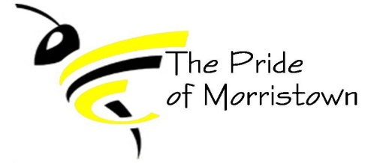
Morristown Band Boosters
Monthly Board Meeting
April 20, 2022

Board Members (X if present):
[X] Band Director – Sam Thrasher [X] President – Amber Richardson
[X] Vice President – Jenny Kieninger [X] Treasurer – Erin Carlton
[X] Secretary – Jenn Deak [ ] Member At Large – Open
Other booster members present: Natalie and Eric Roots, Angie Townsend, and Tracey Rice

Agenda:

Minutes
- Treasurer Report (10 minutes)
  - Current Account Balances
    - Booster: $8,341.30
    - Instrument: $1,676.31
  - Recent expenses:

  - Recent expenses-Not included in balances above:
    - $25.58- check paid to J. Deak for decorations and supplies for banquet
  - Upcoming expenses:

  - Recent Income- Not included in balances above
    - $350.00 – Donation from the Deak family
    - $788.00 – Flower Fundraiser
    - $15.00 – Cash donations during flower fundraiser
  - Other financial concerns/comments:
    - Triton paying half of banquet, but we still owe $106.00 for patches and show shirts. Therefore, we took the $106 out their half of the banquet; so Triton owes $116.29
    - Old Trophies – Silent Auction ???
- Kudos/Happy News (5 minutes):
  - This Friday is ISSMA at Shelbyville H.S.
  - Students are turning in practice log sheets!
  - 22-23 SY students interested in band is high – about half of fifth grade class!
  - Spring Band Concert is May 6th!

- Key Points/actions from last meeting (15 minutes)
  - Approval of March minutes: J. Kieninger motioned to approve; seconded by E. Carlton; all ayes.
  - Waiting on school corporation to give us new plates for the smaller trailer (title has been signed over) *Update* Email has been sent to Chris Scott, waiting for reply. Still Waiting!!-A. Richardson is going to call.
- Band Director Report (15 minutes)
  - ISSMA contests – High School Concert Band is Friday
  - Marching Band parent information meeting is Monday, May 2nd at 7:00 pm
    - J. Kieninger is emailing Mr. Powers about funds to help families with marching band fees
  - Band Camp July 18th-29th
    - July 29th is Community Show
    - Derby Days is on July 30th
- Fundraising (20 minutes)
  - Flower Fundraiser – Orders come in on April 22nd for students to deliver
  - Car Wash?
    - Last week of band camp?
  - Calendar Sales:
    - J. Deak obtained athletic director’s email again to email him about dates for calendar
    - J. Deak will be emailing the calendar order form to S. Thrasher and committee to provide to students to sell

- Other topics/open discussion
  - Derby Days –
  - Election of officers was held. The following were nominated at the last meeting:
President-Jenn Deak
Vice President-Angie Townsend
Treasurer-Erin Carlton
Secretary-Tracey Rice
Member at Large-Natalie and Eric Roots
    - Ballots were cast and tallied – The above nominations were voted as is.

Next Meeting 5/18/2022 @ 6:30

