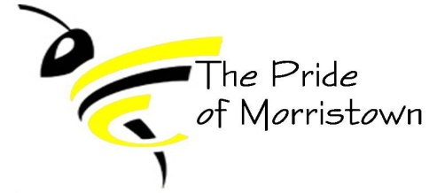
Morristown Band Boosters
Monthly Board Meeting
January 18, 2022

Board Members (X if present):
[X] Band Director – Sam Thrasher [X] President – Amber Richardson
[X] Vice President – Jenny Kieninger [ ] Treasurer – Erin Carlton
[X] Secretary – Jenn Deak [ ] Member At Large – Open
Other booster members present:

Agenda:

Minutes
- Treasurer Report (10 minutes)
  - Current Account Balances
    - Booster: $11,430.91
    - Instrument: $1,676.31
  - Recent expenses:

  - Recent expenses-Not included in balances above:

  - Upcoming expenses:
    - P.O. Box $62.00 for the year – A. Richardson will get a check from E. Carlton and pay
  - Recent Income- Not included in balances above
    - $7 – Calendar Money from J. Deak
  - Other financial concerns/comments:
    - S. Thrasher provided receipt for tarp that was purchased
    - December 29th game sold 1 bag of popcorn and 1 calendar
    - January 11th game sold 4 bags of popcorn
- Kudos/Happy News (5 minutes):
  - Homecoming this Saturday and Pep Band is playing – game is at 6 pm
  - Students working hard to prepare for solo and ensemble competition

- Key Points/actions from last meeting (15 minutes)
  - Approval of December minutes: J. Kieninger motioned to approve; seconded by J. Deak; all ayes.
  - Waiting on school corporation to give us new plates for the smaller trailer (title has been signed over) *Update* Email has been sent to Chris Scott, waiting for reply. Still Waiting
- Band Director Report (15 minutes)
  - Winter Percussion: Have 3 Morristown students participating
  - Winter Guard: Down to just 2 Morristown students
    - Need a parent to volunteer to take students to competitions – Boosters are willing to reimburse for mileage
  - ISMAA Jazz Band competition in March
  - County Band Day is March 7th at Waldron

- Fundraising (20 minutes)
  - Calendar Sales:
    - Sell at basketball games – Sold at two games; we didn’t sell very many.
    - *Paula will begin selling ads in April
  - Popcorn – received flyers/brochures. Students begin selling the week of January 24th and orders are due back to Mr. Thrasher by Monday, February 14th
  - Flower Fundraiser – Flower brochures will be mailed to J. Kieninger within the next couple of weeks. Potential selling dates are March 14th through the first week of April
  - Car Wash in May is still up for a possibility.
    - Additional Car Wash during band camp week in the summer?
- Other topics/open discussion
  - Senior Night is February 11th – anything else other than the cow bells needed to be taken care of? No
    - Paper for students to fill out. – S. Thrasher has
  - Next Meeting – Meet and greet with parents and potential new band boosters at 6:00 pm. A. Richardson bringing a copy of the bylaws and chips, J. Kieninger bringing a veggie tray, and then we will also have popcorn and water bottles from the band room to provide additional refreshments.

Next Meeting 2/15/2022 @ 6:00

